Exploratory Data Analysis on Wildfire Data

Austin F. Phillips
Department of Computer and Information Sciences
Towson University, Maryland 21251, USA
Email: aphil3535@students.towson.edu

- INTRODUCTION
Big data refers to the vast and complex datasets that cannot be processed and analyzed using traditional data processing methods. The emergence of big data has revolutionized the way businesses, organizations, and governments approach data management and analysis. With the advent of new technologies such as cloud computing, machine learning, and the Internet of Things (IoT), big data has become a crucial resource for gaining insights and making informed decisions. The analysis of big data allows organizations to identify patterns, trends, and correlations that were previously hidden, which can lead to improved efficiency, better customer experiences, and innovative solutions.
Data mining, on the other hand, is the process of extracting valuable and useful information from large datasets. It involves applying statistical and machine learning techniques to identify patterns and relationships within the data. Data mining is used across various domains such as business, healthcare, finance, and science, to uncover hidden insights, trends, and patterns that can be used for decision-making. The process of data mining includes data preparation, data modeling, data analysis, and result interpretation. It helps organizations to optimize their operations, improve customer satisfaction, reduce costs, and increase revenue. Data mining is an essential component of the big data ecosystem, enabling organizations to extract meaningful insights from vast amounts of data.
The discussion presented in this paper explores the causes of wildfires and the burn acreage during these catastrophic events. In order to do this we used the data on forest fires provided by UC Irvine’s Machine Learning Repository. This dataset provides data from the northeast region of Portugal through meteorological and other means.

The following sections of this paper are organized as follows: Section II presents a fundamental description of the introduced datasets. Section III outlines the preprocessing steps taken to prepare the data. In Section IV, we conduct an exploratory data analysis and present preliminary results. Section V includes a regression analysis and the development of a predictive model. Lastly, in Section VI, concluding remarks are provided.
- DATA DESCRIPTION

- Attributes
The dataset contains 517 data points, each having 13 attributes:
1. X - x-axis spatial coordinate within the Montesinho park map: 1 to 9
2. Y - y-axis spatial coordinate within the Montesinho park map: 2 to 9
3. month - month of the year: 'jan' to 'dec'
4. day - day of the week: 'mon' to 'sun'
5. FFMC - FFMC index from the FWI system: 18.7 to 96.20
6. DMC - DMC index from the FWI system: 1.1 to 291.3
7. DC - DC index from the FWI system: 7.9 to 860.6
8. ISI - ISI index from the FWI system: 0.0 to 56.10
9. temp - temperature in Celsius degrees: 2.2 to 33.30
10. RH - relative humidity in %: 15.0 to 100
11. wind - wind speed in km/h: 0.40 to 9.40
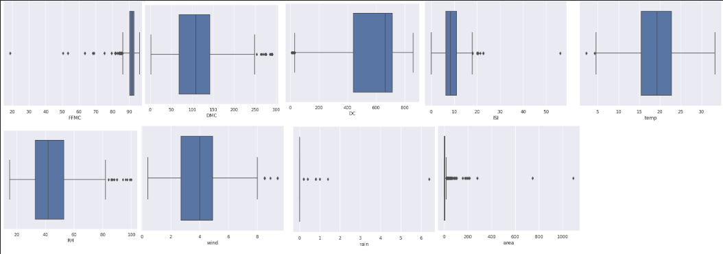
Fig. 1. Boxplots of nine of the eleven numeric attributes (FEMC, DMC, DC, ISI, temp, RH, wind, rain, area)

12. rain - outside rain in mm/m2 : 0.0 to 6.4
13. area - the burned area of the forest (in ha): 0.00 to 1090.84
There are two string variables (month and day) and eleven numeric variables (x, y, FEMC, DMC, DC, ISI, temp, RH, wind, rain, area). We are going to focus on the predictive power of FEMC, DMC, DC, ISI, temp, and wind.
- Statistics on Data
One of the best ways to understand the data the is being worked on is to run a few basic statistical equations on the dataset. To better grasp the data, we looked at the box plot of the initial data. Figure 1 shows the boxplots of the data points in each attribute. Clearly there are extreme outliers for some of the attributes and some not as extreme. Further analysis within the context of the dataset tells us that for the predictiveness of area burned we will have to consider the outliers, as most of the data is 0 for burning or else the data point would be too few.
- DATA PREPROCESSING
Data preprocessing is a crucial step in analyzing and evaluating raw datasets. Particularly in the context of Big Data, data preprocessing and cleaning are essential for mitigating unintended errors in collected data, ensuring the removal of personally identifying information, and handling outliers and anomalies. As the generation of big data from various devices becomes massive, the likelihood of data errors also increases exponentially. In this section, we
discuss the methods for data cleaning and normalization, which are necessary for conducting comparative analysis.
- Data Cleanse
Section II showed us that we had a few outliers. We want to keep these outliers as most of the important data can be derived from these to predict the burn acreage of forest fires as well as predict them.
In addition, we checked for any duplicate entries to which we came across four. They were removed as well. Also, the variables X, Y, month, day were deemed unnecessary to the data.
We also binned the data into 30 bins as the natural data looked sloppy, as visualized in Figure 2.
- Normalization
Figure 2 shows us that some of the data is relatively normal while others are not. Therefore, normalization is necessary. In Figure 3 we used Min-Max normalization, Figure 4 we used Z-Score normalization, and Figure 5 we used kernel density estimation (KDE). All the data points were binned into 30 bins before conducting the transformations and normalization as this was a larger group of data.
There were no significant changes that occurred through any of these processes besides making the data shift a little. With this information we then decided to move onto other normalization methods to really help the variables FFMC, RH, and Wind. The next methods we tried were Natural Log 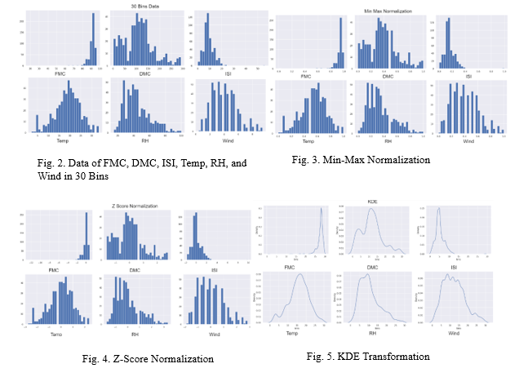Transformation and Inverse Square Root Transformation as observed in Figure 6 and 7.
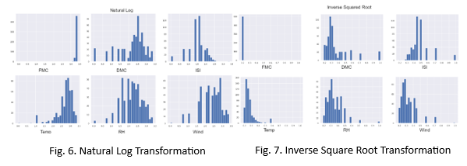
Upon looking at the Natural Log and Inverse Square root transformations we can see that it does not help much except for ISI with the natural log transformation which relatively unskewed the data. These transformations are all still using 30 bins mine you.
The next route to try to find normality was through looking at the Normal Probability Plots. Again the dataset is still binned at 30 bins. Figure 8 visualizes that plots and uncovers close to normality in the RH, wind, FMC, and ISI which at least was expected fromISI as per the natural log transformation from
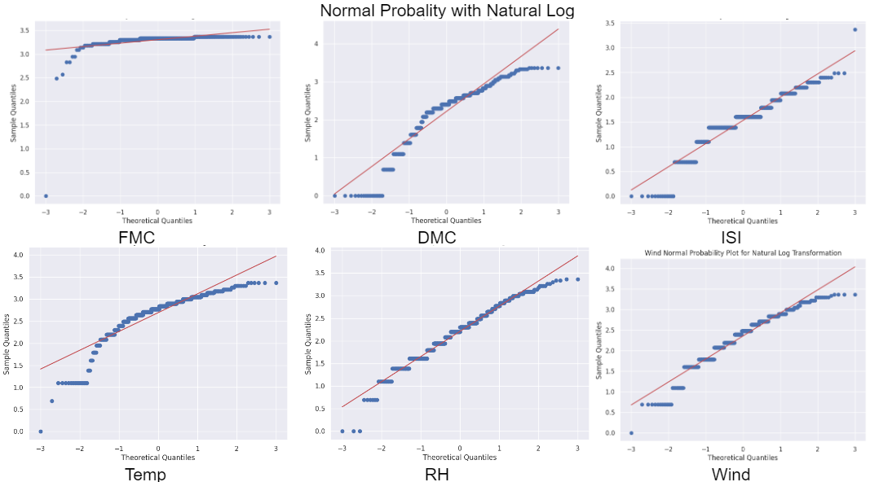

Fig. 8. Normal Probability Plots

before. The others are not far off from normality so it can be safe to proceed.
IV. EXPLORATORY DATA ANALYSIS
As observed, most of the dataset is not normal but that does not mean there is no correlation. In fact, we can observe a strong positive correlation between temperature, relative humidity, and wind speed, which are all important factors in predicting forest fires. So, we can consider the efforts a small success. Another aspect in correlation are scatter matrix plots and as shown in Figure 9, we see a relative positive correlation between temp and DMC, ISI and DMC. We also see a negative in Temp and RH which is expected as logically temperature decreases the humidity follows.
V. REGRESSION ANALYSIS
After all the exploration of the data through various statical methods we next put the dataset through a regression analysis. Observations in the dataset show correlation between temp and DMC, ISI and DMC. To predict our initial question of investigating predictions of the amount of area burned

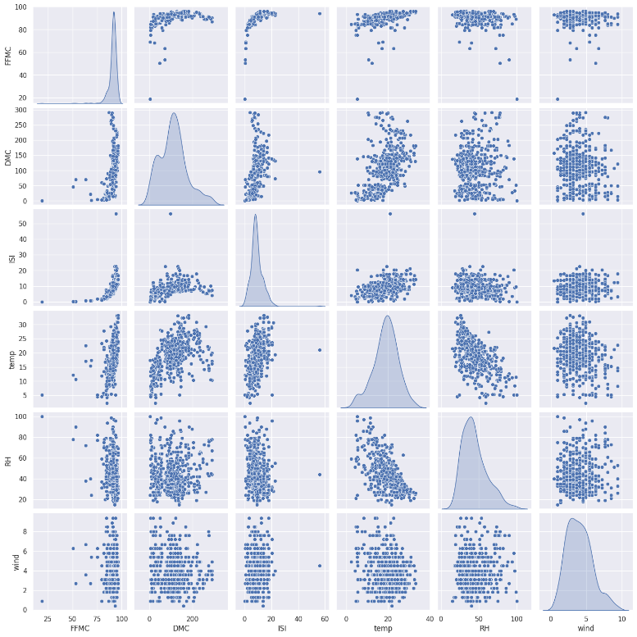
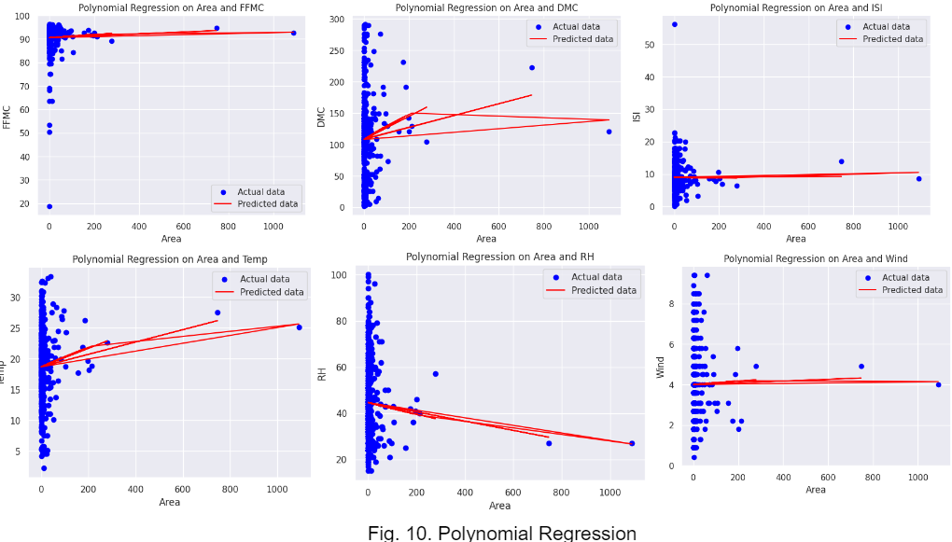
in wildfires we will conduct an regression analysis on the following attributes: FFMC, DMC, ISI, Temp, RH, and Wind. The model will inversely correlate the aforementioned attributes with the area to hopefully create a good prediction .
Figure 10 shows the result of the regression analysis. We used a polynomial regression over a linear on for a better predict as the data itself is still volatile after all the transformations we made. The analysis is unsuccessful for some of the data while for others it works relatively well. This is due to the lack of data in the more extreme cases which are considered outliers but are unfortunately necessary. But what we can observe is the trend in FFMC, ISI, RH and wind. DMC and temp are not as important when it comes to the spreading of the wildfires, but that does not rule out there contributing factor to at least starting them.
VI. CONCLUSION
Practitioners can leverage data mining techniques to extract valuable insights from diverse and correlated data sets. However, before effective analysis can take place, it's necessary to preprocess noisy and anomalous data. Visualizing the data can also aid in understanding it intuitively. In our study, we utilized these principles to make precise predictions

using regression analysis. We carefully examined the data, evaluated the necessity for data transformation, and performed preprocessing and exploratory analysis to identify the most promising predictive attributes. Through our polynomial regression analysis we found out the important variables in predicting the area in which a wildfire may spread through FFMC, ISI, RH and wind.

